Name: _____Li Xianzhe______ Student ID number __2022214880_

Score: ____________________ / 100

**Laboratory 3: Voltage & Current Dividers**

# EE188L Electrical Engineering I

**NAU + CQUPT (Fall 2019)**

# Objectives

At the completion of this lab, the student will be able to:

1. Create a current divider circuit. Measuring current on a DMM.
2. Create a voltage divider circuit
3. Use the function generator
4. Become familiar with an oscilloscope

# Material needed

1. Following resistors: 47k, 30k, 10k (2), 3.9k, 1.3k
2. DC Power Supply
3. DMM
4. Function Generator
5. Oscilloscope

**Grading:**

Activity #1 / 25 Activity #2 _________ / 25

Activity #3 / 25 Activity #4 / 25

# Important Concepts

1. Two resistors in parallel form a current divider circuit. The resistors split the current in **inverse proportion** to their resistances: the higher resistance has the lower current flowing through it, and vice-versa.
2. Two resistors in series form a voltage divider, which is a useful circuit combination to step down voltages in transducers or in filter circuits. A voltage divider splits the voltage supplied to the series combination, so that the voltages are in the same proportion as the resistances. If the two resistors are equal, they have the same voltage (half each). If one resistor is three times the other, that one gets three times the voltage across it (or ¾ of the total).
3. An oscilloscope is an instrument that can display several AC waveforms or signals over time on a screen much like a TV screen. The oscilloscope can measure a variety of things associated with those waveforms like the peak voltage, the phase difference between waveforms and much more.

# Activity #1 – Introduction to a Current Divider

1. First, connect two of the resistors (10k and 10k) in parallel on the Protoboard and measure the equivalent resistance of the total.
2. Connect 100 $μ$ A from the DC Power supply to the parallel combination. (**Since this is not possible in our lab, we will use the circuit shown below to create an approximately constant 100 $μ$ A source, using 5 vdc from the power supply and a 47k resistor).**
3. First, connect the DMM **in series** with the 47k resistor, and measure $I_{S. }$. Then, connect the DMM in series with each resistor, and measure the current flowing in it. Enter the current values in Table 1
4. Disconnect the power supply, and Repeat steps 1 to 3 above using the other pair of resistors (30k and 10k) in parallel. Record values in Table 1.

R2

R1

DC Current

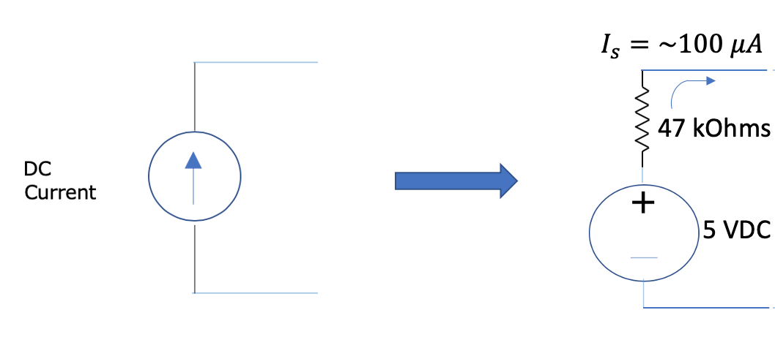

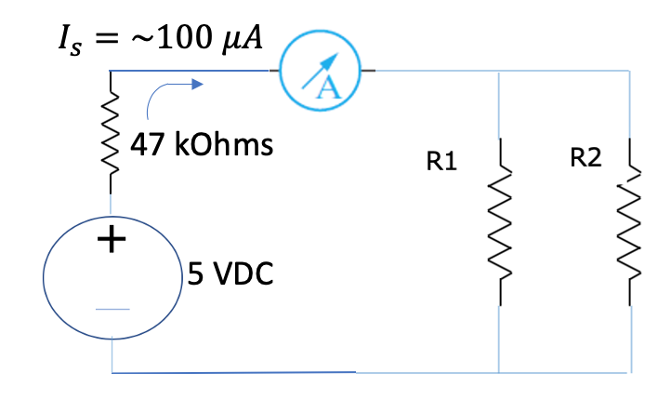

**Table 1. Current Divider - Currents**

|  |  |  |  |  |  |
| --- | --- | --- | --- | --- | --- |
| Resistances in Parallel | Source Current $I_{S}$ ( $μA)$ | Current ( $I_{1})$ in R1  Calculated Measured | | Current ( $I_{2})$ in R2  Calculated Measured | |
| R1 = 10k,  R2 = 10k | 96.665 | 48.154 | 48.626 | 48.154 | 48.492 |
| R1 = 30k  R2 = 10k | 92.589 | 22.95 | 22.874 | 68.85 | 69.721 |

Q. Write the 2-resistor current divider formula here.

I1=[R2/(R1+R2)]*Is I2=[R1/(R1+R2)]*Is

1. What can you conclude about how the current is being divided between the two resistors in parallel?

When connected in parallel, due to the series voltage division, the higher the resistor divides the higher the voltage, and the lower the resistance, the lower the voltage

# Activity #2 – Introduction to a Voltage Divider

Our goal is to provide a 5 volts supply to load resistor RL.

1. First, connect two of the resistors (30k and 10k) in series on the Protoboard and measure the resistance of the total. Apply **20 vdc** from the DC Power supply to the series combination.

R1

+

DC Voltage

R2

RL

R1

2. Measure the voltage across R2 (the 10k resistor). It should read close to 5 volts.

1. Now, connect the load resistor (RL, also 10k) in parallel to R2. Measure the voltage across the parallel combination. Record the value in Table 2.
2. Repeat Steps 1 to 4 using the other pair of resistors for R1 and R2 (3.9k and 1.3k). Again, record values in Table 2.

**Table 2. Voltage Divider - Voltages**

|  |  |  |  |  |
| --- | --- | --- | --- | --- |
| Resistances in Series | Open Voltage across $R_{2}$ (without $R_{L})$ Calculated Measured | | Voltage across $R_{2}$ with load $R_{L}$ connected  Calculated Measured | |
| R1 = 30k,  R2 = 10k | 5V | 4.937V | 2.857V | 2.823V |
| R1 = 3.9k  R2 = 1.3k | 5V | 5.026V | 4.55V | 4.579V |

Q. Write the voltage divider formula here.

V1=[R1/(R1+R2)]*Vtotal V2=[R2/(R1+R2)]*Vtotal

1. Which R1, R2 combination above is better and why?

The combination of R1=3.9k and R2=1.3k is better, because the resistance of 1.3k is less than 10k, and the effect is smaller when connected in parallel with RL

**Activity #3 – Function Generator**

In this activity, we will use the function generator to create an AC or periodic waveform, i.e., a waveform that repeats over and over. Examples are square waves, triangular waves and sinusoidal waves. We will apply the sinusoid voltage to the Series resistor combination.

Connect the terminals of the function generator across two resistors R1 & R2 (3.9k and 1.3k) in series on the protoboard. You will measure AC voltage by pressing the other Voltage button on the DMM, the one with the sinusoidal line next to the V.

Set the buttons on the function generator for a 100 KHz sinusoidal waveform and adjust the output level knob until you measure **5 volts rms** with the DMM. Measure VRX across each resistor and enter in the first column in Table 3.

## Table 3. AC Voltages Across Each Resistor

|  |  |
| --- | --- |
|  | VRX for 5 V AC Measured |
| R1 | 3.641V |
| R2 | 1.245V |

**Q. What can you say about the magnitude of the voltages across the two resistors? Are the values similar or different than with a DC voltage source?**

The voltage ratio between the two resistors is still equal to the ratio of their resistors, is the value similar to a DC voltage source?

**Activity #4 – Introduction to the Oscilloscope**

The oscilloscope is a measurement instrument that shows waveforms as functions of time on a small screen like a TV. You can display 2 or 4 waveforms at the same time depending on the scope model at your bench.

1. Turn on the oscilloscope with the POWER button located at the lower left. Connect the scope probe for channel 1 across both resistors in series, the voltage you will read is just the Source voltage. You should be able to see the waveform on the oscilloscope.
2. **Note that the black alligator ground clips for both the oscilloscope and function generator must also always be connected to the same terminal.**
3. Connect the scope probe for channel 2 to the top (+ve) of the resistor R2 only. You should see the second voltage waveform across this resistor too.

1. You must now be seeing 2 sinusoidal waveforms. Turn the Position and Scale knobs to see what they do. Get the largest waveform you can and between 1-3 cycles of the waveform showing. Move the zero line to the middle of the screen.

1. adjust the function generator so that the AC output value when measured by the DMM is again *VAC* = 5 Vrms. Record this in the Table 4 for the source voltage. Also, measure and write the voltage across R2.

A grid of 10X8 dotted rectangles are displayed behind the waveforms on the oscilloscope. The voltage scale (shown at the bottom of the display) tells you the value of the height of each rectangle. Looking at the oscilloscope, estimate *Vmagnitude* (by observing the zero to peak value) of the waveform across the resistor combination.

The peak value should be higher than the rms value by a factor of the square root of 2, i.e. peak value is (5 $\sqrt{2}$* ) = 7.07 volts for the source voltage.

## Table 4. Voltages Across the Source and R2, Oscilloscope Attached

|  |  |  |
| --- | --- | --- |
|  | AC Voltage Measured with DMM | Peak Voltage Measured on Scope |
| Channel 1 or Vsource | 4.810V | 7.2V |
| Channel 2 or VR2 | 1.235V | 1.81V |

**Q. What is the ratio of the peak voltages of the source & across R2? Do these Peak voltages also satisfy the voltage Divider formula?**

$\sqrt{2}$, These peak voltages also satisfy the divider formula.

**Have your lab instructor or aide sign below in order to receive credit for this lab:**

Signature _____________________________________ Date ______________

